DS5006 Final Project, Xao Yiao, Touhid Islam, Rachel Hurley
EEG-Based Modeling of Cognitive State and Workload in an Architectural Design

1. Introduction
This project examines whether EEG-derived features can be used to model cognitive state and perceived workload during architectural design tasks. The analysis focuses on two supervised learning problems. The first is a classification task, where EEG features are used to distinguish between different task conditions. The second is a regression task, where EEG features are used to predict self-reported workload scores. The project uses summary EEG features extracted from task-level recordings collected during controlled design activities. The current goal is not to make broad claims about design cognition, but to evaluate whether the available EEG features contain enough information to support these two prediction problems in a small-sample setting.

1.1 Description of the Data
The dataset was collected from 34 participants who completed two architectural design phases. The first phase, Task 1, was a brain-only design task lasting approximately 30 minutes. The second phase, Task 2, was also approximately 30 minutes and involved either conventional search or GenAI-assisted revision. EEG was recorded continuously throughout the experiment using 16 wet electrodes sampled at 500 Hz, with coverage over the frontal, central, and parietal regions. After each task, participants completed a post-task self-report survey used to measure subjective workload. For modeling, the main analysis uses a task-level feature table, where each row corresponds to one participant-task combination and each column corresponds to an EEG-derived feature or outcome variable.

1.2 Description of the Problem
This project addresses two related machine learning problems based on the same EEG feature set.
The first problem is a classification task. Here, the goal is to determine whether EEG features can distinguish between different design conditions, especially whether task-related brain activity differs between non-AI conditions and ChatGPT-assisted design. This is treated as a supervised classification problem in which the predictors are EEG-derived task-level features and the response variable is the task condition label.
The second problem is a regression task. In this case, the goal is to predict self-reported workload from EEG-derived features. The target can be either the average workload score or individual workload question items. This is a more difficult problem because the sample size is small relative to the number of predictors, and subjective workload may not have a simple or stable relationship with the extracted EEG variables.
Both tasks therefore involve a small-sample, high-dimensional learning problem. The main challenge is not simply fitting a model, but evaluating whether the extracted EEG features generalize well enough to support reliable prediction under subject-level cross-validation.

1.3 Data Preprocessing and Feature Extraction
Before modeling, the EEG signals were preprocessed to improve signal quality and reduce noise and artifacts. The preprocessing pipeline included removal of the first 2 seconds of data, application of a 60 Hz notch filter, RANSAC-based bad channel detection, average re-referencing, and bandpass filtering from 0.5 to 44 Hz. After this, independent component analysis (ICA) using extended infomax was applied, and artifact-related components were identified with ICLabel and removed before reconstructing the cleaned EEG signal.
Feature extraction was then performed at both the task level. The extracted EEG features included absolute and relative band power in the delta, theta, alpha, and beta bands; mean frequency features; and several ratio measures, such as theta/beta and (alpha + theta)/beta. Additional features included RMS, variance, coefficient of variation, line length, Hjorth parameters, spectral entropy, permutation entropy, and frontal alpha asymmetry. Window-based features were further summarized using statistics such as mean, standard deviation, and slope, producing the final feature matrix used for the current machine learning tasks.

2. Methods and Results
2.1 Task 1: Classification
2.1.1 Data preparation
All analysis is done in python (Python, 2026). To prepare data for classification, firstly hierarchical cross-validation is necessary. Data from four participants (four Brain Only tasks, two Search, two ChatGPT) are saved for final testing. This reduces the dataframe size to 60 (88% of total data). Additionally when training and testing, the data will be normalized using “standardscalar” so that the mean and standard deviation are 0 and 1, respectively. And we will also use GroupKFold cross-validation for model selection, which ensures that each subject is contained within either the training or testing data to try to avoid data leakage of the machine learning algorithm mistakenly memorizing individual participants (scikit-learn, 2026).

2.1.2 Regularization: Lasso and Ridge Regression
This data set is also particularly challenging because of the abundance of features. Therefore, regularization techniques, Ridge and Lasso, are the first models to be chosen for a Logistic Regression. We will initially use cross validation to choose the penalty term, lambda, that optimizes the test accuracy. Lasso applies the L1 regularization which operates by penalizing absolute value of the coefficients and removing features. Ridge uses L2 regularization by adding a penalty to the square of the coefficients, thus retaining all coefficients but shrinking some values to avoid overfitting (geeksforgeeks, 2025).
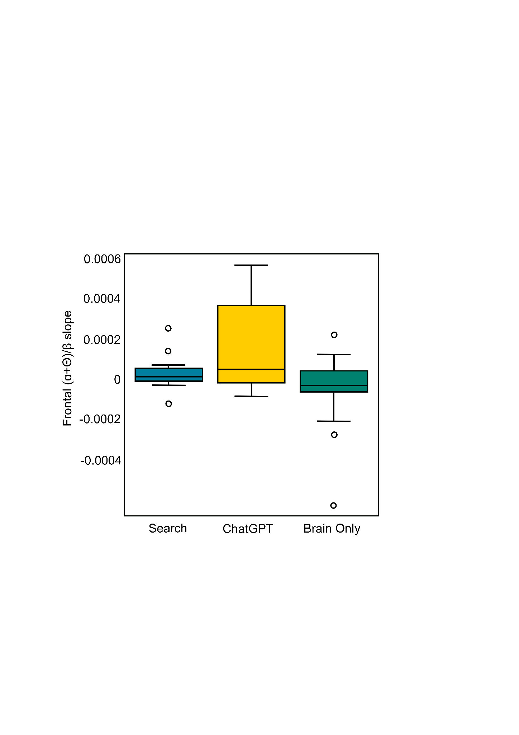

Figure 2.1. Boxplot of highest-ranking lambda feature for Lasso regression.
For the initial lasso model the Lambda that optimizes the test accuracy, 21.5, was too high as a result penalized all coefficients to zero therefore the model was simply randomly guessing. However by guessing, since there are twice as many Brain Only participants as there are search and ChatGPT this enabled a testing accuracy of 50%. To prevent lasso from penalizing all terms to zero we limit the lasso lambda value to 10. With this restriction, the new optimal Lambda was 2.78 and was able to achieve a training accuracy of 76.7% and testing accuracy of 45% and retained 24 features. Although this model is more useful, there is a high level of overfitting. By examining the top three features for the lasso we find that the band ratios (ɑ+Θ)/β slope for the frontal region is the most influential. Particularly, the ChatGPT group experienced higher levels. A higher (ɑ+Θ)/β indicates fatigue(Yu-Long & Y.-L. Pei, 2018), therefore, this suggests that by using ChatGPT, students become less vigilant at a faster rate.
Instead of lasso we can use Ridge regression that instead of penalizing coefficients shrinks coefficients to zero to avoid the potential of losing all coefficients. However this approach proves to be as challenging as lasso but instead of overly penalizing and removing terms, Ridge retains all coefficients and features and therefore the training accuracy is very at 100% while the testing accuracy is 46.7%, an extreme case of overfitting. As a result, when viewing the most influential features from the Ridge, there are not very clear patterns because all features are being used.

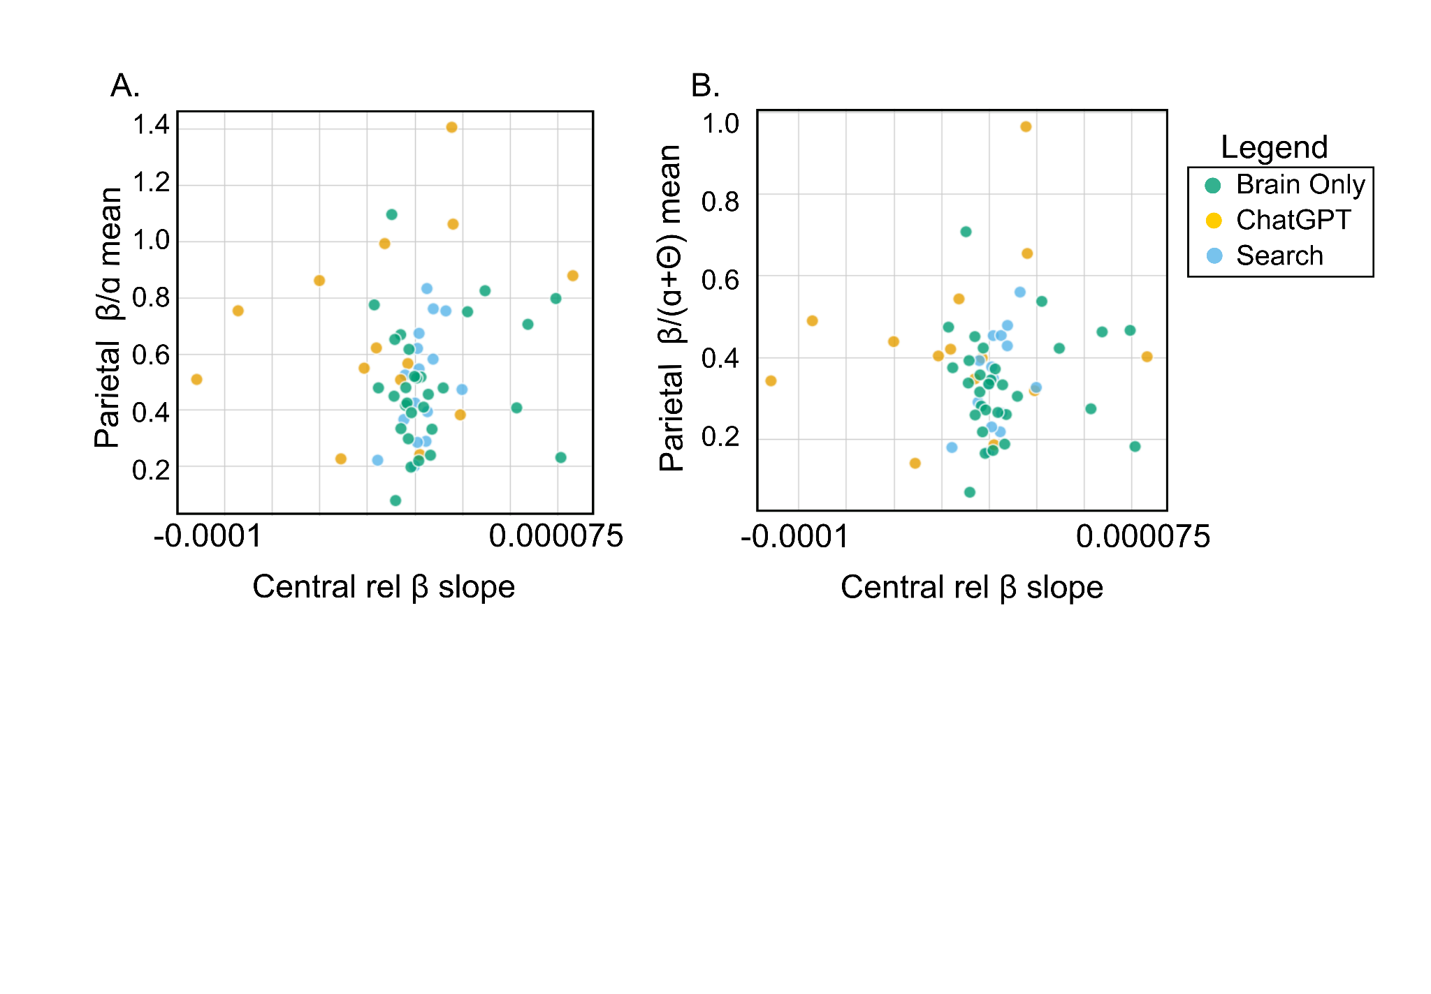

Figure 2.2. Scatter plots of the most influential features, Ridge Regression.
Similarly to Lasso regression, we will set a specific maximum Lambda value to ensure that we don't retain every single feature but reduce the dimensionality of the data by defining a Lambda of 1,000. With this new penalty, the training accuracy drops to 64.2% while the test accuracy remains similarly at 45%. Although still overfitting, as the training accuracy is over 20% higher than the testing accuracy, this is an improvement. We can better understand the data by creating Scatter Plots of different features and how the three categories, Search, ChatGPT and Brain Only, are distributed among these features.

By plotting the central relative β slope versus the parietal ratio β/ɑ mean, two important features according to the Ridge regression, the ChatGPT group has lower values of the central relative β slope compared to the main cluster for the Search and the Brain Only. Outliers in the Brain Only group have higher central relative β slope values. A lower band frequency β, although less investigated in creativity research, indicates smoother motor ability (Mirabella et al., 2026).

2.1.3 Feature Selection
As demonstrated by the abundance of features, it is important to use domain knowledge to further reduce the number of features included into our model. Proven important band ratios include the Θ/ꞵ band ratio (TBR) and the (ɑ+Θ)/ꞵ band ratios. The TBR corresponds to attention (Wu et al., 2026) while the (ɑ+Θ)/ꞵ indicates sleepiness (Wang et al., 2025). Another useful measure includes the frontal ɑ asymmetry, is calculated as the log(ɑ power at the right front) - log(ɑ power at the left front). A higher value means that people are taking approach behaviors such as anger or optimism, while higher negative value is associated with withdrawal behavior such as depression or anxiety (Smith et al., 2017). Research has also shown that including mean frequency, absolute power, and relative power is useful for classification of resting versus working memory states (Javaid et al., 2022). Finally, examining only one brain region may be sufficient. By including these features, the data dimensionality can be reduced by over half to 68 features.

However, many of the retained features are still highly correlated. For instance, central (ɑ+Θ)/ꞵ mean and central TBR mean, as well as the same measures but slope and the slope for the frontal and parietal region are correlated above 0.95 Pearson’s R. Therefore by removing features with high correlations over 80% and maintaining as many important variables, 30 features can be removed, resulting in 38 total.

2.1.4 Random Forest First and Further Dimension Reduction
Random Forest is an appropriate approach for classification problems and outperforms other algorithms (Maito et al., 2023). The problem still remains that the training accuracy is at 100% while the testing accuracy is at 53.3%. Random Forest is robust to overfitting because it does not include any information based on outcome variables and values when creating each tree. However, Random Forest can overfit if allowed to grow to a maximum depth (Pious et al., 2024). Therefore, upon looking at the Random Forest more closely, the problem is that the tree is not restricted by the number of branches and nodes that it can have and the number of samples that it needs to look at when making each decision at the nodes. Therefore, the Random Forest can make a very large tree, with one sample per decision, and in fact overfit. After specifying the depth to two and ensuring each leaf includes at least 5 samples before making a decision two additional splits and each Leaf much look at 5 samples before making a decision, the testing error stays at 53.3%, but the training error is lowered to 89.2%, which helps to limit, but not eliminate, overfitting.

The number of features after selection, 38, is still too high of the dimensionality for only 34 (31 after hierarchical cross validation) participants with two data points per participant. Therefore, further feature engineering is very important such as using dimension reduction with Principal Component Analysis (PCA). Additionally, examining only one specific region which would reduce the number of features by ⅓. Finally, there is little distinction among the search compared to the Brain Only behaviors based on visualization of the data. It could be beneficial to investigate whether the machine learning algorithm can correctly identify those using AI or tattoo BT compared to Brain Only or search and thus instead of a three class classification problem instead a binary classification problem.

In starting with PCA the screen plot shows at 12 components is a sufficient number of components to use moving forward in the analysis using the Kaiser Criterion (although for datasets with many features can retain too many). By comparing the PCA plot of PC1 versus PC2 we see the similar trend of outliers for certain ChatGPT participants. Particularly, this group experiences higher values of PC1 compared to the other groups. When further inspecting the features of PC1 and PC2, the components of each in fact tend to be for one specific region.
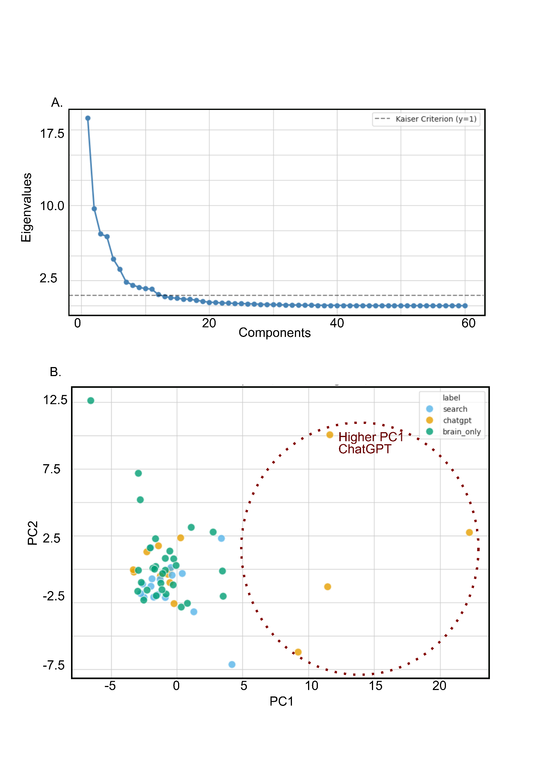
Figure 2.3. (A) Scree plot and (B) PC1 vs PC2 for Random Forest.

Creating a decision tree can be useful to see how the algorithm makes different decisions based on different components. In looking at the tree, it is clear that the algorithm has a very difficult time identifying Brain Only versus search and actually in the particular tree plotted it doesn't predict Brain Only at all but defaults to search. For certain values of different principal components it identifies ChatGPT. Thus the accuracy cannot be much improved but instead the classification problem should be adjusted to identify ChatGPT versus no AI. Using PCA and trying to predict ChatGPT versus not AI, the PC with the highest importance is primarily composed of mean frequency data. However, there are some problems. While the training accuracy is nearly 100% the testing accuracy is around 70 to 75%. Although this testing accuracy is higher, it is imperative to recall that the distribution of the data is not equal when in fact 25% of the data is actually ChatGPT while 75% is not AI. Therefore the algorithm could perform very respectively while just guessing not AI for every single prediction. This will be considered later in the analysis.
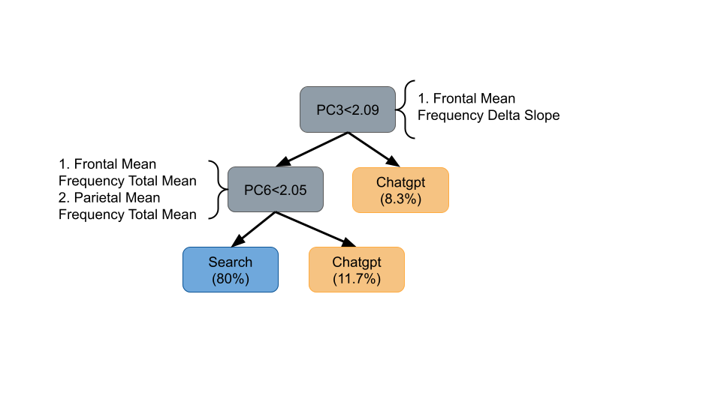

Figure 2.4. Decision Tree for visualization.
When using a Random Forest for each of the three regions, frontal, central and parietal, the frontal region appears as prominent avenues for analysis. The training and testing error for the frontal region is 96.3% and 71.6%, respectively when only including mean frequency data. When using all features for this region, which includes asymmetric data, the training and testing accuracies are 93.3% and 78.3%. This is a 15% discrepancy, which is greatly improved related to the risk of overfitting.

2.1.5 Final Model and Validation
Reducing features is an effective strategy. Therefore, if it is possible to fit the data with only a handful of features, this will be very useful for not only improving testing accuracy, but can be useful for future studies by requiring less data to be collected via fewer channels.

Finally, in a model with fewer features for ChatGPT vs no AI, scaling must occur subject specifically. This will reduce intersubject variability and has been used for this research in EEG data (Frøkjær et al., 2017). Using this approach and only including two features for the random forest, the features selected are frontal Θ/β slope and frontal (ɑ+Θ)/β slope with a training and testing accuracy of 95.8% and 86.7%, respectively.

The model must finally be tested on the hierarchical cross-validation safe data. The testing accuracy on this data is 87.5% with one ChatGPT outcome incorrectly identified. However, the largest limitation of this data is the low sample size, only leaving four participants for testing.

2.1.6 Five-Minute Data Test
For each task, 30 minutes worth of data was collected. We test our final model again on the data but only examining the first five minutes of data collection. If comparable results are found, then less data and experimental resources are required to distinguish between using AI and non-AI for design tasks.

We find that the first five minutes of each task does perform more poorly for the model, a testing accuracy of 55.8%. However, as “slope” features are the most important, we also investigate how well the mean frontal Θ/β and frontal (ɑ+Θ)/β perform. Accuracy is improved but still lower at 75%. When assessing the mean frontal Θ/β and frontal (ɑ+Θ)/β for the 5-min and full 30-min sessions, the results are fascinating. While the non AI group values remain largely unchanged, the ChatGPT group values increase by 25-28% when comparing the 5-min task to full task.

Table 2.1. Mean values for mean-top two features for different session durations
Feature | Analysis Window | Mean (ChatGPT) | Mean (Non-AI) | Cohen's d | p-Value
Frontal Theta/Beta | Full Session | 0.339 | 0.255 | 0.591 (Med) | 0.156
 | 5-Min | 0.264 | 0.271 | -0.052 | 0.867
Alpha-Theta / Beta | Full Session | 0.559 | 0.444 | 0.522 (Med) | 0.202
 | 5-Min | 0.446 | 0.452 | -0.027 | 0.937

2.1.7 Major Findings and Conclusion
When looking at the data, the ChatGPT group is clustered at higher values for frontal Θ/β slope and frontal (ɑ+Θ)/β slope. Elevated Θ/β has been associated with attention-deficit and hyperactivity disorder (Angelidis et al., 2016). Therefore, our results indicate that using ChatGPT may lead to elevated increases in lack of attention control during design tasks. Moverover, higher values of (ɑ+Θ)/β correspond with increased drowsiness, therefore, using ChatGPT leads to a progressively more relaxed state (Wang et al., 2025). Moreover, these measures related to attention and relaxation are found to be influential in determining AI usage in design tasks. However, when testing the Random Forest model on the first 5 minutes of data only, the accuracy dropped to 55.8%. Therefore, the changes in these features are not suitable for accuracy predictions in a shorter task time period. However, when looking at the mean value of these features over the first five minutes, accuracy improves to 75%. Moreover, the values of the mean frontal Θ/β and frontal (ɑ+Θ)/β are much lower for the ChatGPT group over the first 5 rather than the whole 30 minutes of the task, showing that these values increase when using AI throughout the design task.

2.1.8 Unsupervised Learning, ChatGPT Anomalies
While the majority of classification tasks in this project have relied on supervised learning, an unsupervised approach is also tested. By windowing participant data into 5-second intervals, the dataset was expanded by over 500 rows. An Autoencoder paired with K-means clustering is used to compress the high-dimensional data into a latent space before applying clustering techniques to uncover underlying patterns. This has been used in EEG research (Prabhudesai et al., 2019). This technique is used to understand patterns between the ChatGPT and search group and ChatGPT and Brain only.

By plotting the latent clusters for both datasets, it becomes evident that while ChatGPT results differ from traditional search results, they do not form two distinct clusters. This lack of clear separation suggests that the neural signatures of using AI and the internet are similar for many participants. Instead, the groups are primarily distinguished by numerous anomalies within the ChatGPT data. This is further supported by the reconstruction error, the variance between input and reconstructed output, where the ChatGPT group exhibited higher error rates. This increased error, alongside the presence of high-density outliers in the box and scatter plots, confirms that the ChatGPT data is inherently more volatile and contains a higher degree of noise compared to standard search tasks.
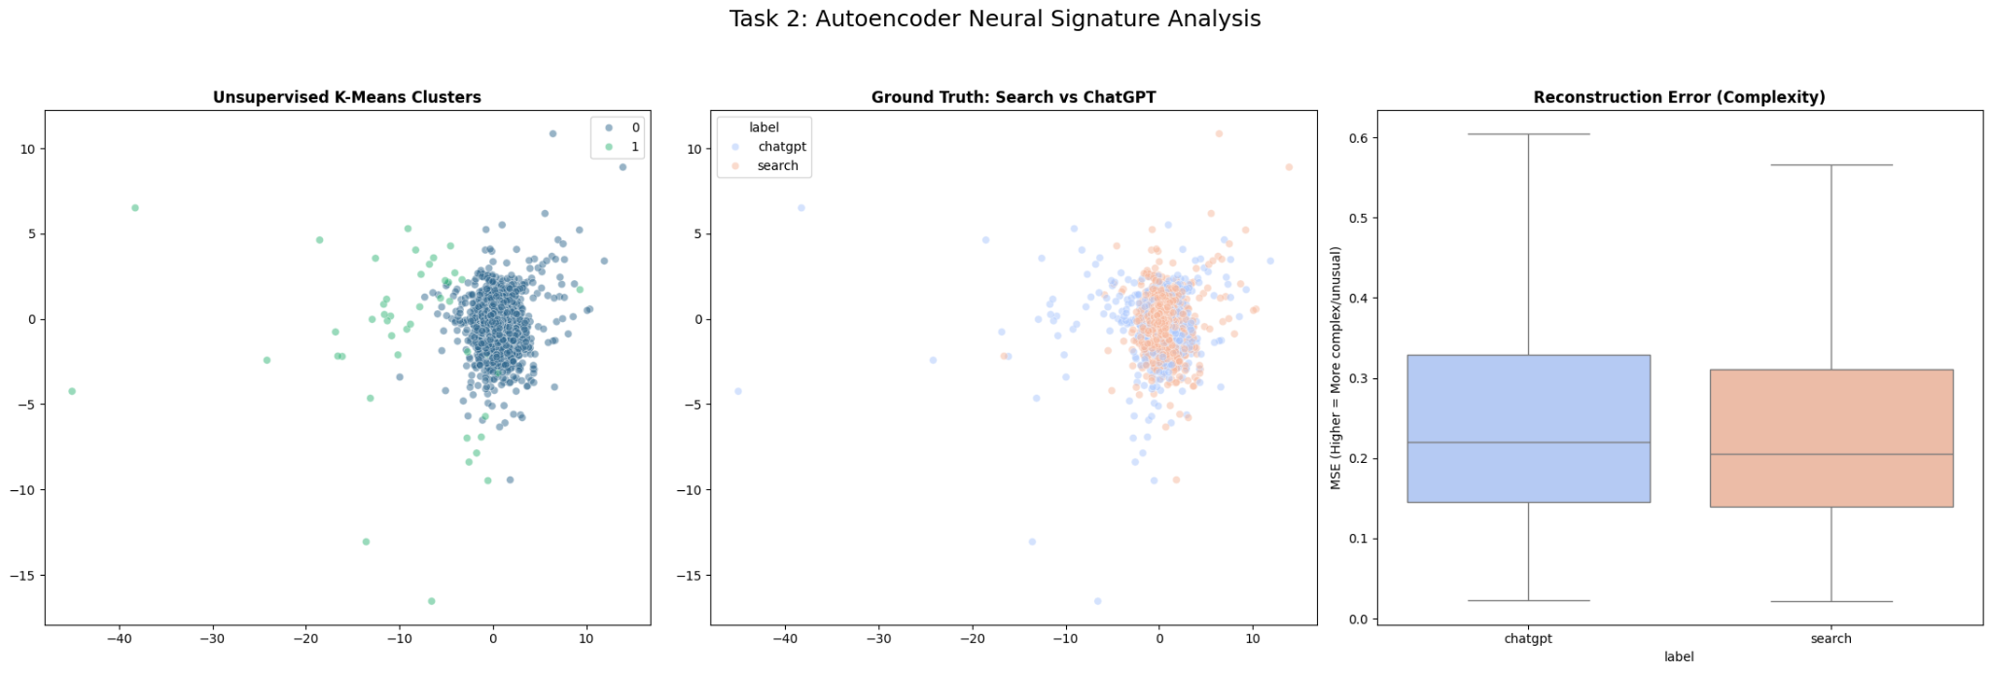
Figure 2.5. Autoencoder and Kmeans clustering shows abnormalities in ChatGPT data
Now, the ChatGPT vs Brain only are compared using the Autoencoder paired with K-means clustering approach. This is slightly improved, as the ChatGPT data clearly diverges from the main cluster of the Brain Only data, however, the reconstruction error is similar to the above comparison. However, this is preliminary, as more data collected related to eye tracking, facial expressions, or EEG data while painting can improve the clustering results.
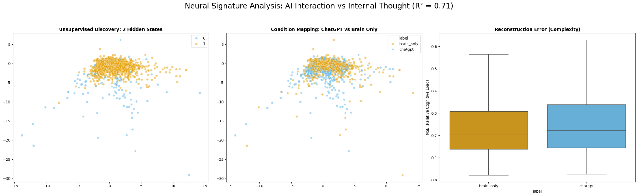
Figure 2.6. Autoencoder and Kmeans clustering for Brain Only and ChatGPT data

2.2 Task 2: Regression

The goal was to predict average workload using EEG-derived features under two different task settings. The analysis was carried out on a high-dimensional feature space consisting of EEG summary variables extracted from frontal, central, and parietal regions, along with several derived statistical, spectral, and entropy-based measures
Although the original dataset contained 68 rows and 278 columns, the actual predictive modeling was performed separately on two 34-row subsets corresponding to Task 1 (“Brain only”) and Task 2 (“Search or ChatGPT”). Each subset contained 258 predictor variables and a single workload-related target. This setup immediately introduced a small-sample, high-dimensional regression problem

The first broad issue was overfitting because of the high dimensionality of the data. For that reason, principal component analysis (PCA) was adopted as a dimensionality reduction step. PCA transforms the original correlated variables into a smaller set of orthogonal components that preserve most of the variance in the feature space. This was especially appropriate here because many EEG features are likely to be correlated with one another, both within and across brain regions.

In both task settings, PCA retained more than 95% of the explained variance while reducing the feature space to 16 components for Task 2 and 18 components for Task 1. This reduction substantially lowered model complexity. Instead of directly stating that a specific EEG feature predicts workload, the model operates on weighted combinations of many underlying features. In other words, PCA supported prediction but made it harder to explain the result physiologically at the feature level.

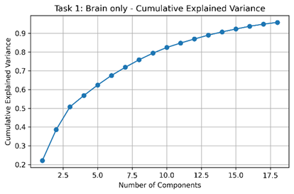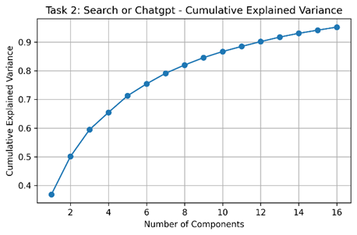
Figure 2.7. Number of components for each task after PCA

After dimensionality reduction, multiple regression models were compared. The candidate models included Ridge regression, Lasso regression, Elastic Net, support vector regression (SVR), and Random Forest. These models were selected for good methodological reasons. Ridge regression is often useful when many predictors are weakly informative and correlated, since it shrinks coefficients without eliminating them entirely. Lasso can perform both shrinkage and feature selection, which can be attractive in high-dimensional problems. Elastic Net combines the strengths of Ridge and Lasso and is often recommended when groups of correlated predictors are present. SVR was included because nonlinear relationships between EEG activity and subjective workload are plausible, and SVR can capture such patterns better than purely linear models. Random Forest was also included as a flexible nonlinear baseline capable of capturing feature interactions without requiring explicit parametric assumptions.
Cross-validation was used to compare models rather than relying only on a single train-test split. This was important because with only 34 samples in each task subset, a single split can produce unstable or misleading impressions of model quality. Cross-validation provided a more robust estimate of out-of-sample performance by repeatedly training and validating across different partitions of the data.

SVR achieved the best cross-validation mean R^2 among all models, although that value remained slightly negative at approximately -0.057. Its training R^2was 0.8464, indicating that it could fit the training data well, but its test R^2 dropped to -0.2226. This pattern points to overfitting or weak underlying signals. The train MAE and RMSE were 0.1489 and 0.2032, respectively, while the corresponding test values worsened to 0.4688 and 0.5863. These results suggest that although the model could learn patterns from the training set, those patterns did not generalize reliably to unseen samples.

For Task 1 (“Brain only”), the picture was even weaker. PCA selected 18 components and retained about 95.81% of the explained variance, again indicating that dimensionality reduction was effective in compressing the feature space. SVR still ranked first based on cross-validation mean R^2, but that mean was approximately -0.750, much worse than in Task 2. The training R^2 for SVR was 0.6944, while the test R^2 was -0.3437. The train MAE and RMSE were 0.1378 and 0.2342, and the test MAE and RMSE were 0.2795 and 0.3534. Although some of the absolute error values were not enormous, the negative test R^2 indicates that the model performed worse than a naive baseline that simply predicts the mean target value. That is an important result because it means the model failed to capture a stable predictive mapping from EEG features to workload in this task setting.

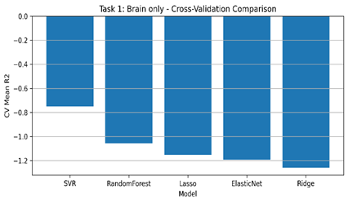 | 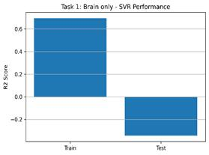
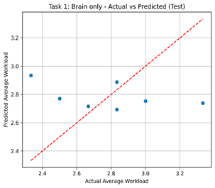

Figure 2.8. Performance parameters for Task 1

Table 2.Numerical summary of parameters for Task 1
Model | CV_R2_Mean | CV_R2_STD | Train_R2 | Test_R2 | Train_MAE | Test_MAE | Train_  RMSE | Test_  RMSE
SVR | -0.749 | 1.113 | 0.694 | -0.343 | 0.137 | 0.279 | 0.234 | 0.353
RandomForest | -1.057 | 1.095 | 0.853 | -0.725 | 0.123 | 0.332 | 0.162 | 0.400
Lasso | -1.151 | 0.894 | 0.781 | -5.268 | 0.138 | 0.629 | 0.198 | 0.763
Elastic Net | -1.191 | 0.908 | 0.799 | -6.071 | 0.134 | 0.660 | 0.189 | 0.810
Ridge | -1.258 | 0.926 | 0.807 | -7.176 | 0.134 | 0.697 | 0.185 | 0.871

Comparing the two tasks, Task 2 appears more predictable than Task 1. Its best model had a cross-validation score close to zero rather than strongly negative, and some models such as Random Forest produced slightly positive test R^2, though not enough to override their poor validation behavior. This suggests that the relation between EEG-derived features and workload may differ by task context, and that the Search/ChatGPT task could contain more usable predictive structure than the Brain-only task. Even so, neither task produced convincing evidence of robust predictive success.

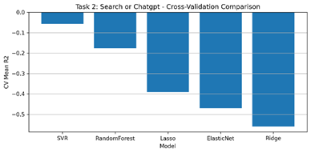 | 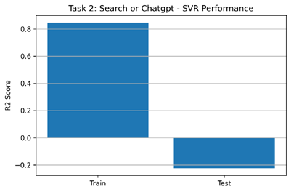
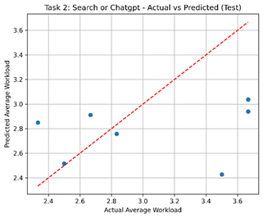
Figure 2.9.Performance parameters for Task 2

Table 2.Numerical summary of parameters for Task 2
Model | CV_R2_Mean | CV_R2_STD | Train_R2 | Test_R2 | Train_MAE | Test_MAE | Train_  RMSE | Test_  RMSE
SVR | -0.057 | 0.164 | 0.846 | -0.222 | 0.148 | 0.468 | 0.203 | 0.586
Random Forest | -0.176 | 0.423 | 0.844 | 0.044 | 0.163 | 0.479 | 0.204 | 0.518
Lasso | -0.390 | 0.727 | 0.745 | -0.049 | 0.207 | 0.467 | 0.261 | 0.543
Elastic Net | -0.470 | 0.832 | 0.760 | -0.089 | 0.197 | 0.478 | 0.253 | 0.553
Ridge | -0.559 | 0.945 | 0.766 | -0.131 | 0.187 | 0.487 | 0.250 | 0.563

2.2.2 Regression Conclusions
Several conclusions can be drawn from this part of the project, both positive and negative. On the positive side, the analysis established a clear and reasonable modeling pipeline for a difficult high-dimensional EEG regression problem. The combination of preprocessing, PCA-based dimensionality reduction, and model comparison across regularized linear and nonlinear methods was methodologically sound. The work also showed that nonlinear models, particularly SVR, may be more promising than penalized linear models for this type of workload prediction problem.
At the same time, the negative findings are more important. The results do not support a strong claim that average workload can be predicted reliably from the available EEG-derived features in these small task-specific subsets. The repeated appearance of negative cross-validation and test R^2values suggests that the models are not generalizing well. In practical terms, this means the current dataset and feature pipeline do not yet provide a stable predictive tool for workload estimation. High training scores alone would have been misleading; the validation and test results show that apparent in-sample success does not translate into dependable out-of-sample performance.
A further conclusion is that sample size is likely a major limiting factor. With only 34 observations per task and 258 predictors before PCA, the models are operating in a setting where noise can easily dominate signals. Future improvements would likely depend less on switching among standard algorithms and more on increasing the number of observations, improving feature quality, introducing more task-specific or physiologically informed features, and possibly using nested cross-validation and hyperparameter tuning to reduce selection bias.
In summary, the final approach of PCA followed by SVR was the best among the tested methods, but its performance remained limited. The main value of this project is therefore not that it produced a highly accurate predictor, but that it identified the difficulty of the problem in a transparent and methodologically grounded way. It showed which classes of models are relatively more promising, which approaches were less successful, and why stronger conclusions about prediction should be avoided at this stage.

References
Angelidis, A., Van Der Does, W., Schakel, L., & Putman, P. (2016). Frontal EEG theta/beta ratio as an electrophysiological marker for attentional control and its test-retest reliability. Biological Psychology, 121, 49–52. https://doi.org/10.1016/j.biopsycho.2016.09.008
Frøkjær, J. B., Graversen, C., Brock, C., Khodayari-Rostamabad, A., Olesen, S. S., Hansen, T. M., Søfteland, E., Simrén, M., & Drewes, A. M. (2017). Integrity of central nervous function in diabetes mellitus assessed by resting state EEG frequency analysis and source localization. Journal of Diabetes and Its Complications, 31(2), 400–406. https://doi.org/10.1016/j.jdiacomp.2016.11.003
geeksforgeeks. (2025, July 23). Ridge Regression vs Lasso Regression. https://www.geeksforgeeks.org/machine-learning/ridge-regression-vs-lasso-regression/
Javaid, H., Manor, R., Kumarnsit, E., & Chatpun, S. (2022). Decision Tree in Working Memory Task Effectively Characterizes EEG Signals in Healthy Aging Adults. IRBM, 43(6), 705–714. https://doi.org/10.1016/j.irbm.2021.12.001
Maito, M. A., Santamaría-García, H., Moguilner, S., Possin, K. L., Godoy, M. E., Avila-Funes, J. A., Behrens, M. I., Brusco, I. L., Bruno, M. A., Cardona, J. F., Custodio, N., García, A. M., Javandel, S., Lopera, F., Matallana, D. L., Miller, B., Okada De Oliveira, M., Pina-Escudero, S. D., Slachevsky, A., … Ibañez, A. (2023). Classification of Alzheimer’s disease and frontotemporal dementia using routine clinical and cognitive measures across multicentric underrepresented samples: A cross sectional observational study. The Lancet Regional Health - Americas, 17, 100387. https://doi.org/10.1016/j.lana.2022.100387
Mirabella, G., Borboni, A., Guerreschi, M., Suppa, A., & Amici, C. (2026). Is neurofeedback A reliable therapy for managing Parkinson’s Disease? Clinical Neurophysiology, 187, 2111890. https://doi.org/10.1016/j.clinph.2026.2111890
Pious, I. K., Rajalakshmi, A., R, P. K., C M, V., Nalini, M., & R, S. S. (2024). Enhancing Prediction Accuracy Through Random Forest in Classification and Regression. 2024 International Conference on Smart Technologies for Sustainable Development Goals (ICSTSDG), 1–6. https://doi.org/10.1109/ICSTSDG61998.2024.11026358
Prabhudesai, K. S., Collins, L. M., & Mainsah, B. O. (2019). Automated feature learning using deep convolutional auto-encoder neural network for clustering electroencephalograms into sleep stages. 2019 9th International IEEE/EMBS Conference on Neural Engineering (NER), 937–940. https://doi.org/10.1109/NER.2019.8716996
Python (Version 3.12.13). (2026). [Google Collaboratory]. https://colab.research.google.com/
scikit-learn. (n.d.). GroupKFold. Retrieved https://scikit-learn.org/stable/modules/generated/sklearn.model_selection.GroupKFold.html
Smith, E. E., Reznik, S. J., Stewart, J. L., & Allen, J. J. B. (2017). Assessing and conceptualizing frontal EEG asymmetry: An updated primer on recording, processing, analyzing, and interpreting frontal alpha asymmetry. International Journal of Psychophysiology, 111, 98–114. https://doi.org/10.1016/j.ijpsycho.2016.11.005
Wang, C., Gao, Y., Cheng, X., Hu, X., Solovey, E. T., Lin, Y., & Liu, S. (2025). The influence of in-car air quality on drivers’ brain states with hybrid fNIRS and EEG. Building and Environment, 286, 113678. https://doi.org/10.1016/j.buildenv.2025.113678
Wu, Y., Ma, D., Song, Y., Ning, X., & Xu, Z. (2026). Attentional function and nocturnal electroencephalography theta/beta ratio in children with rapid-eye movement sleep-related obstructive sleep apnea. Sleep Medicine, 139, 108723. https://doi.org/10.1016/j.sleep.2025.108723
Yu-Long & Y.-L. Pei. (2018). Fatigue Characteristics in Drivers of Different Ages Based on Analysis of EEG. Zhongguo Gonglu Xuebao/China Journal of Highway and Transport, 31(4), 59–77.

